Appendix 3
Institutional Self Study

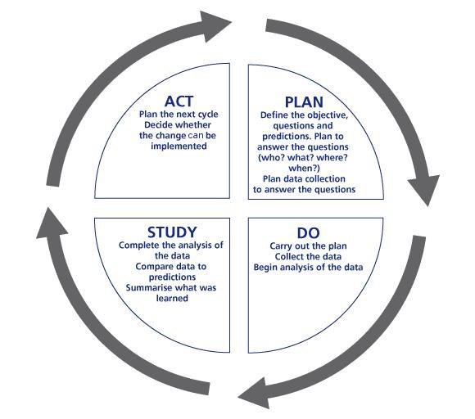
A Plan-Do-Act-Study Approach to Oversight

DEFINITION
The ACGME Institutional Self-Study is the first step of the institutional accreditation process which incorporates a PDSA model for evaluation. The Institutional Self-Study consists of a longitudinal review of the institution based on successive Annual Institutional Reviews (AIR), ACGME Resident and Faculty Surveys, and ACGME Letters of Notification. The AIR and corresponding documentation of corrective action plans with follow up are the backbone of this process.

TIMELINE (assumptions based on ACGME Program Self-Study Timeline)
- Program notification of Self-Study (6-7 months in advance of submission date)
- Self-Study accreditation site visit 12-18 months after Self-Study submission date
- Conduct a minimum of 6 monthly meetings with Self-Study committee members
- One month prior to Self-Study Accreditation Site Visit, program progress update report

DATA SOURCES
- Annual Institutional Review
Corrective Action Status Report
- ACGME Resident and Faculty Surveys
- ACGME Program Letters
- GME Annual Program Evaluations
- Other institutional documents

INSTITUTIONAL SELF-STUDY EIGHT STEP PROCESS
Step 1- Assemble the Self-Study Group
- Identify the Program Education Committee (PEC) for the Self-Study (DIO, Dean or his designee, Sentara leadership, program directors, residents, fellows, nursing, etc.)
- Office of GME will review the Self-Study process with the program
- Office of GME will set expectations for the Self-Study process
Step 2- Discuss Evaluations and Surveys
- Review recent Annual Program Evaluation and ADS survey data
  - Review the ADS survey areas that were identified below 80% compliance. Do any of those areas effect the development of the program aims?
- Identify key stakeholders
- Create a survey to send out to the stakeholders – determine method of survey and distribute
- Collect data from the survey over the next month
- Answer question 1 on the Self-Study application – Program Description
Step 3 Strengths, Weakness, Opportunities, Threats (SWOT Analysis)
- The AIR provides a longitudinal view of strengths and weaknesses
- Identify Strengths (What works well for the institution and should be continued?)
- Identify Weakness (What did not work well for the institution?)
- Identify Opportunities
  - Opportunities are not under control of program
  - Would enhance the institution if could access
  - Define opportunities to achieve current program goals and also aims
- Identify Threats
- Threats are not under the control of the program
- If know/anticipate, can help identify mitigation strategies
- Answers questions 4 and 5 of the Self-Study application = Opportunities for the Program and Threats Facing the Program
- See Attachment 1- SWOT Analysis Template
Step 4- Aggregate & Analyze Data
- Discuss survey data returned from the stakeholders.
  - Does the data effect how the program will develop the aims?
  - Revise aims as necessary based on outcomes
  - Gain buy in
- Discuss and develop program aims – approximately 3 – 5
  - Aims are long term and strategic in nature, remain dynamic as the environment changes.
  - “What differentiates our institution?”
  - Define actions necessary to accomplish aims
  - Create activities to advance the newly defined aims
- Answer questions 2 and 3 of the Self-Study application – Program Aims and Program Activities to Advance the Aims
- See Attachment 2 – Guidelines for Establishing Aims Document
- See Attachment 3 – Self-Study Program Aims Template
Step 5- Finalize Aims and Discuss Annual Program Evaluation
- Meet with the stakeholders and provide the data/results from the survey.
- Discuss the program aims and activities that were developed. Make any adjustments as needed.
- Discuss the Annual Program Evaluation Process for the program. How does it occur?
- Answer questions 6 and 7 of the Self- Study application – Annual Program Evaluation Process and Self-Study Process
Step 6- Plans for Improvement
- Develop a Plans for Improvement document.
  - This document will be requested and submitted 12-18 months after the program improvements are identified in the Self-Study.
  - These can be short-term and long-term goals
- Answer question 7a (if applicable) – Self-Study process for Dependent Subspecialty Programs
- Answer question 8 of the Self-Study application – Learning that Occurred During the Self-Study
- See Attachment 4 – Plans for Improvement Template
Step 7- Develop a Succinct Self-Study Document
- Review final ACGME Self-Study application with the Program Education Committee
- Review the Self-Study Update Document
  - This document is due 12 days prior to the Site Visit
- Review Self-Study Achievements Document
  - This document is due 12 days prior to the Site Visit
- Upload Self-Study application to ACGME
  - All 8 questions should be completed and answered within the word count guidelines
Step 9- Start the cycle again at the next AIR

